##### Project report on

**E - Library**

A Dissertation submitted in partial fulfillment of the academic requirements for the

award of the degree.

## Bachelor of Technology

**In**

### Information Technology

Submitted by

Mankala Vinay Kumar (19H51A1238)

Durishetty Navaneeth Sai(19H51A1240)

Tovati kota Chary (19H51A1239)

Mamidishetti Avinash (19H51A1240)

##### 

Under the esteemed guidance of

(Mrs. Tara kumari) (Guide Designation)



**Department of Information Technology**

**CMR College of Engineering & Technology**

(An Autonomous Institution under UGC & JNTUH, Approved by AICTE, Permanently Affiliated to JNTUH, Accredited by NBA.)

**2019- 2023**

##### A Project report on

**E - Library**

###### A Dissertation submitted to JNTU Hyderabad in partial fulfillment of the academic requirements for the award of the degree.

**Bachelor of Technology**

**in**

**Information Technology**

Submitted by

##### Mankala Vinay Kumar-19H51A1238

##### Tovati Kota chary-19H51A1239

##### Durishetty Navaneeth Sai-19H51A1240

##### Mamidishetty Avinash-19H51A1241

Under the esteemed guidance of

(Mrs. Tara kumari) (Guide Designation)



**Department of Information Technology**

**CMR COLLEGE OF ENGINEERING AND TECHNOLOGY**

(An Autonomous Institution under UGC & JNTUH , Approved by AICTE, Permanently Affiliated to JNTUH, Accredited by NBA.)

KANDLAKOYA, MEDCHAL ROAD, HYDERABAD - 501401.

#### 2019- 2023

**CMR COLLEGE OF ENGINEERING & TECHNOLOGY**

KANDLAKOYA, MEDCHAL ROAD, HYDERABAD – 501401

**DEPARTMENT OF INFORMATION TECHNOLOGY**



#### CERTIFICATE

This is to certify that the Mini Project-1 report entitled **"E-Book"** being submitted by **Mankala Vinay kumar(19H51A1238), Tovati Kota Chary(19H51A1239), Durishetty Navaneeth Sai(19H51A1240), Mamidishetti Avinash(19H51A1241)*.*** in partial fulfillment for the award of **Bachelor of Technology in Information Technology**is a record of bonafide work carried out his/her under my guidance and supervision.

###### The results embodies in this project report have not been submitted to any other University or Institute for the award of any Degree.

**Mrs. Tara kumari Dr. K .L.S.Soujanya**

**<designation> Professor and HOD**

**Dept. of IT**

Submitted for viva voice Examination held on

**External Examiner**

**TABLE OF CONTENTS**

|  |  |  |  |  |
| --- | --- | --- | --- | --- |
| **CHAPTER**  **NO.** |  |  | **TITLE** | **PAGE NO.** |
|  | **LIST OF FIGURES** | | |  |
|  | **ABSTRACT** | |  | 7 |
| **1** | **INTRODUCTION** | | | 8 |
|  | 1.1  1.2 | Project Aims & Objectives  Assumptions and Dependencies | | 9 |
|  |  |  | |  |
| **2** | **BACKGROUND WORK** | | |  |
|  | 2.1 | Domain Introduction | | 10 |
|  | 2.2 | Web Development | | 12 |
|  |  | 2.2.1  2.2.2  2.2.3 | React  Html(Hypertext markup language)  CSS(Cascading Style Sheets) | 13 |
|  | 2.3 | Using Kexical Knowledge to evaluate the novelty of rules mined from text | | 18 |
|  |  | 2.3.1 | Text mining | 19 |
| **3** | **PROPOSED SYSTEM** | | | 22 |
|  | 3.1 | Data mining | | 22 |
|  |  | 3.1.1 | Data Representation | 23 |
|  | 3.2 | Text Mining | | 26 |
|  | 3.3 | Text mining and Information Extraction | | 28 |
|  | 3.4 | Integrating Data mining and Information Extraction | | 30 |
|  |  | 3.4.1 Disco TEX system | | 30 |
|  |  | 3.4.2 Using mined rules to improve IE | | 32 |
|  | 3.5 | Performance Analysis | | 34 |
| **4** | **DESIGNING** | |  | 35 |
|  | 4.1 | UML Diagrams | | 35 |
|  | 4.2 | ER Diagrams | | 36 |
| **5** | **RESULTS AND DISCUSSION** | | | 37 |
|  | 5.1 | Graphs |  | 38 |
|  |  | 5.1.1 Precision | | 38 |
|  |  | 5.1.2 Recall | | 39 |
|  |  | 5.1.3 F-measure | | 40 |
| **6** | **CONCLUSION AND FUTUREWORK** | | | 41 |
| **7** | **REFERENCES** | |  | 42 |

**List of Figures**

|  |  |  |
| --- | --- | --- |
| **FIGURE**  **NO.** | **TITLE** | **PAGE**  **NO.** |
| 3.1 | Knowledge Discovery in Database. | 21 |
| 3.2 | Text Data mining | 28 |
| 3.3 | Framework | 32 |

Title of the Project

#### Abstract

#### The Web-Browser has the potential to make information accessible to everyone, as this potential cannot be realized unless content is designed so that all Internet users can access the full range of resources. The use of web content that is accessible to everyone in our daily life, as it consistent with standard information for the learning purpose. The web has become an essential tool for educational activities at all levels. Students both learn from web resources and create web content as well. We are going to create a Website Namely “E - Library”, based on the present Pandemic situation as the student are not able to get access to the Library, as they are too far from it. So we have Decided to Provide the available Textbook source online Through our Website Based on the Courses Based on Computer Science.

CMRCET B.Tech (IT) Page No

# CHAPTER 1

INTRODUCTION

1.1 Project & Aim Objective

Internet has bought a lot of changes in the life of people and we can say everything has become easier after the introduction of internet. Literally everything is available on the internet, from information to news and current affairs. During pandemic the usage of internet has increased a lot and almost everything has become online, from ordering food, accessing information etc. So our aim is to design a website where a student can have access to wide range of books, study materials etc. Users also can contribute to the website by sharing the material or pdf’s they have.

* Online book reading.
* A search column to search availability of books.
* It is an Open Source link for Learning

1.2 Assumptions and Dependencies

* The users should have sufficient knowledge of Technology & of English language, as the user interface will be provided in English.
* The members can be either the student or faculty or any other person, those who are interested in Reading Books.

CHAPTER 2

BACKGROUND WORK

2.1 Domain Introduction

E-Library is a web application which refers to library in which user gets access to the Library Books through our Website. It is used by librarian to read the library books using a Device system where he/she can add new books, and Page sources. Books and source files are also included in this system, which would allow the user keep a copy with them, such that they can access it offline, through E - library and also a detailed description about the books a library contains. Through this Website system, there will be no loss of book record or member record which generally happens when there is no Online system is used. All these modules are able to help the Reader to manage the Books with more convenience and in a more efficient way as compared to library systems which are not accessible.

2.2Web Development



Web Development is the work involved in developing a website for the Internet (World Wide Web) or an intranet (a private network). Web development can range from developing a simple single static page of plain text to complex web applications, electronic businesses, and social network services. A more comprehensive list of tasks to which Web development commonly refers, may include Web engineering, Web design, Web content development, client liaison, client-side/server-side scripting, Web server and network security configuration, and e-commerce development.

For larger organizations and businesses, Web development teams can consist of hundreds of people (Web developers) and follow standard methods like Agile methodologies while developing Web sites. Smaller organizations may only require a single permanent or contracting developer, or secondary assignment to related job positions such as a graphic designer or information systems technician. Web development may be a collaborative effort between departments rather than the domain of a designated department. There are three kinds of Web developer specialization: front-end developer, back-end developer, and full-stack developer. Front-end developers are responsible for behavior and visuals that run in the user browser, while back-end developers deal with the servers.

2.2.1 React



React makes it painless to create interactive UIs. Design simple views for each state in your application, and React will efficiently update and render just the right components when your data changes. Build encapsulated components that manage their own state, then compose them to make complex UIs. Since component logic is written in JavaScript instead of templates, you can easily pass rich data through this Platform.

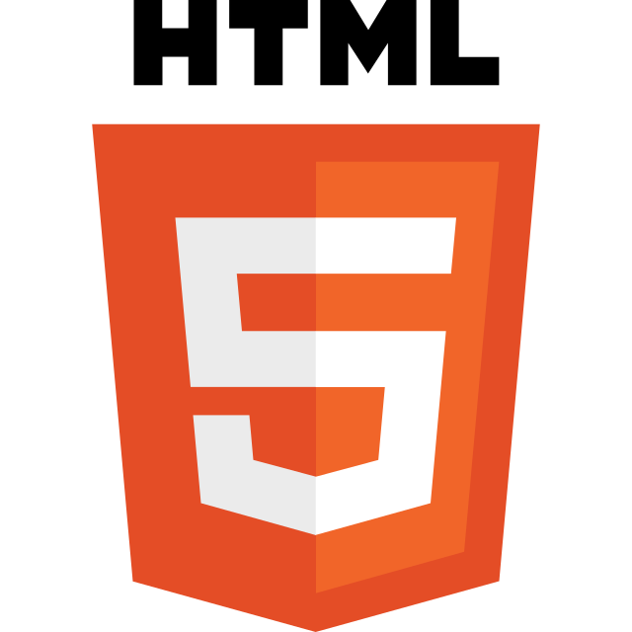2.2.2 html (Hyper Text Markup Language)

HTML is the **language in which most websites are written**. HTML is used to create pages and make them functional. The code used to make them visually appealing is known as CSS and we shall focus on this in a later tutorial. For now, we will focus on **teaching you how to build rather than design**.

Hypertext means that the document contains **links that allow the reader to jump to other places** in the document or to another document altogether. The latest version is known as HTML5. A **Markup Language** is a way that computers speak to each other to control how text is processed and presented. To do this HTML uses two things: tags and **attributes**.

 2.2.3 CSS (Cascading Style Sheets)

Cascading Style Sheets (CSS) is a style sheet language used for describing the presentation of a document written in a markup language such as HTML. CSS is a cornerstone technology of the World Wide Web, alongside HTML and JavaScript.

CSS is designed to enable the separation of presentation and content, including layout, colors, and fonts. This separation can improve content accessibility; provide more flexibility and control in the specification of presentation characteristics; enable multiple web pages to share formatting by specifying the relevant CSS in a separate. css file, which reduces complexity and repetition in the structural content; and enable the. css file to be cached to improve the page load speed between the pages that share the file and its formatting.

2.2.4 Java Script

Java script often abbreviated as JS, is a programming language that conforms to the ECMAScript specification. JavaScript is high-level, often just-in-time compiled and multi-paradigm. It has dynamic typing, prototype-based object-orientation and first-class functions. Alongside HTML and CSS, JavaScript is one of the core technologies of the World Wide Web. Over 97% of websites use it client-side for web page behavior. often incorporating third-party libraries. All major web browsers have a dedicated JavaScript engine to execute the code on the user's device. As a multi-paradigm language, JavaScript supports event-driven, functional, and imperative programming styles. It has application programming interfaces (APIs) for working with text, dates, regular expressions, standard data structures, and the Document Object Model (DOM). The ECMAScript standard does not include any input/output (I/O), such as networking, storage, or graphics facilities. In practice, the web browser or other runtime system provides JavaScript APIs for I/O. JavaScript engines were originally used only in web browsers, but they are now core components of some servers and a variety of applications. The most popular runtime system for this usage is Node.js.

Although there are similarities between JavaScript and Java, including language name, syntax, and respective standard libraries, the two languages are distinct and differ greatly in design.

CHAPTER 3

PROPOSED SYSTEM

* + - * Internet Has made Access to information a lot Easier, People can access any information independent of their location if they are connected to the Internet.
      * But Some Information cannot be accessed simply, as the information is distributed across internet and it is difficult for the user to gather and use the required information.
      * Books on the other hand are somewhat difficult to find on the internet and our proposed solution is to build a website where people can have access to wide range of books
      * it is an open source website where people even have a freedom to upload the books, which are verified by the admin and pushed into the database and finally building a user friendly website.
      * The proposed website consists of a navigation bar through which the user can search the required book and a slider which consist of filters
      * we can search for specific category of books and also a contribute page where the user can upload a book thus contributing to the website
      * It even has an admin feature which enables the admin to delete a specific unwanted information and also update the collection of books.

CHAPTER 4

DESIGNING

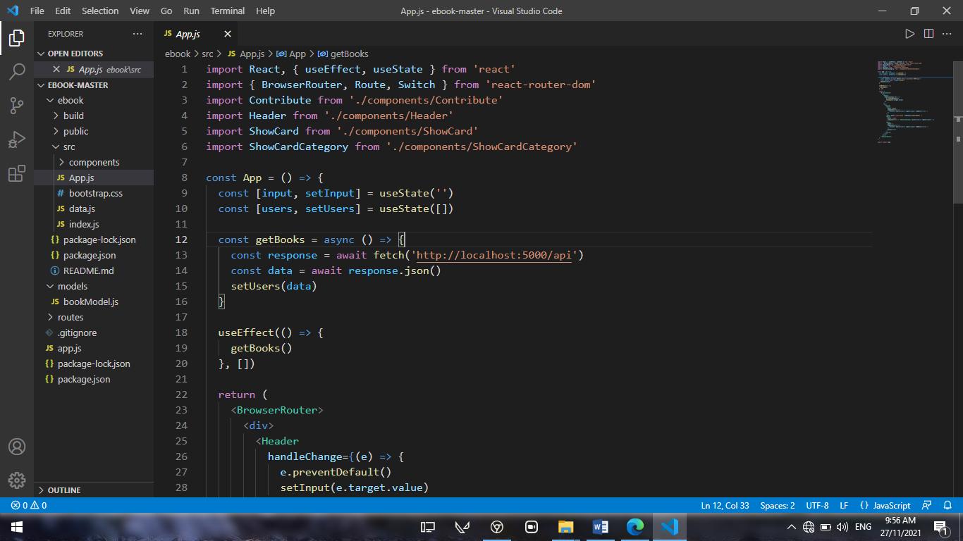4.1 Source Code

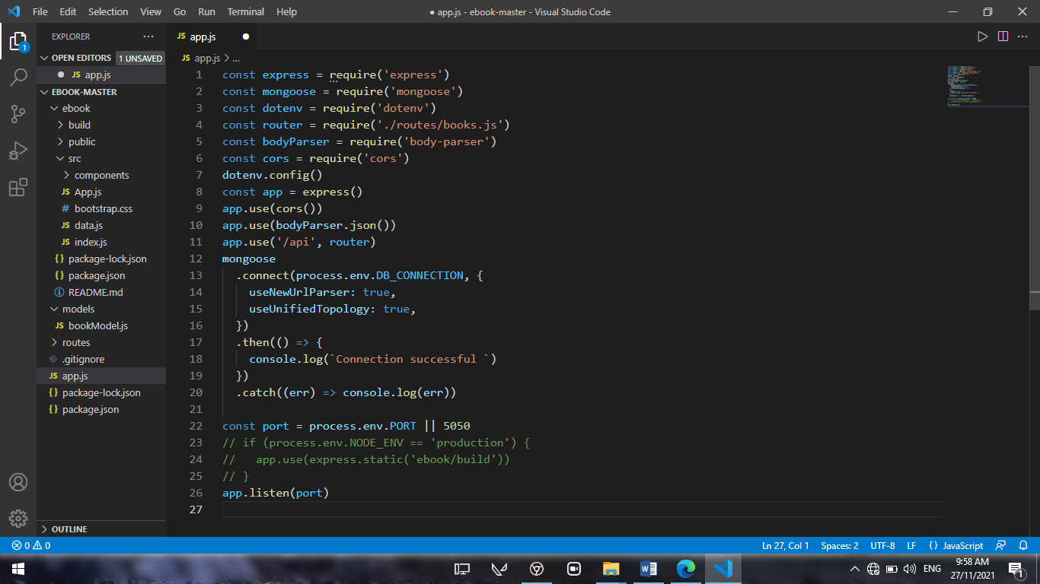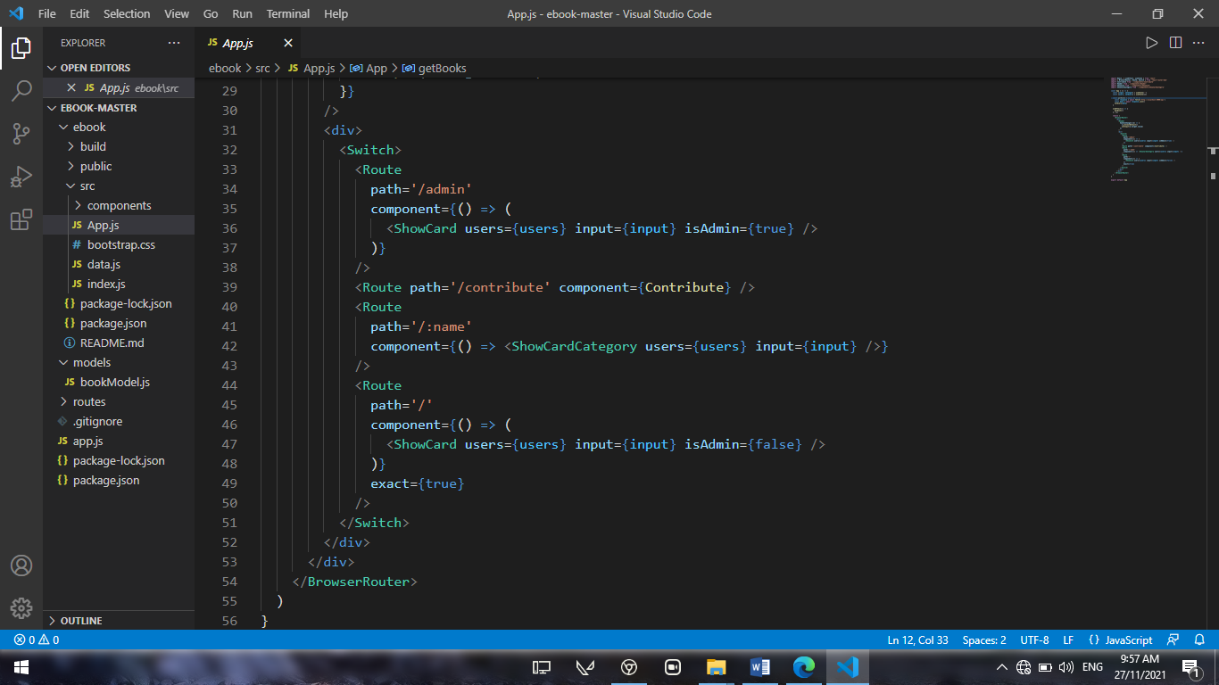

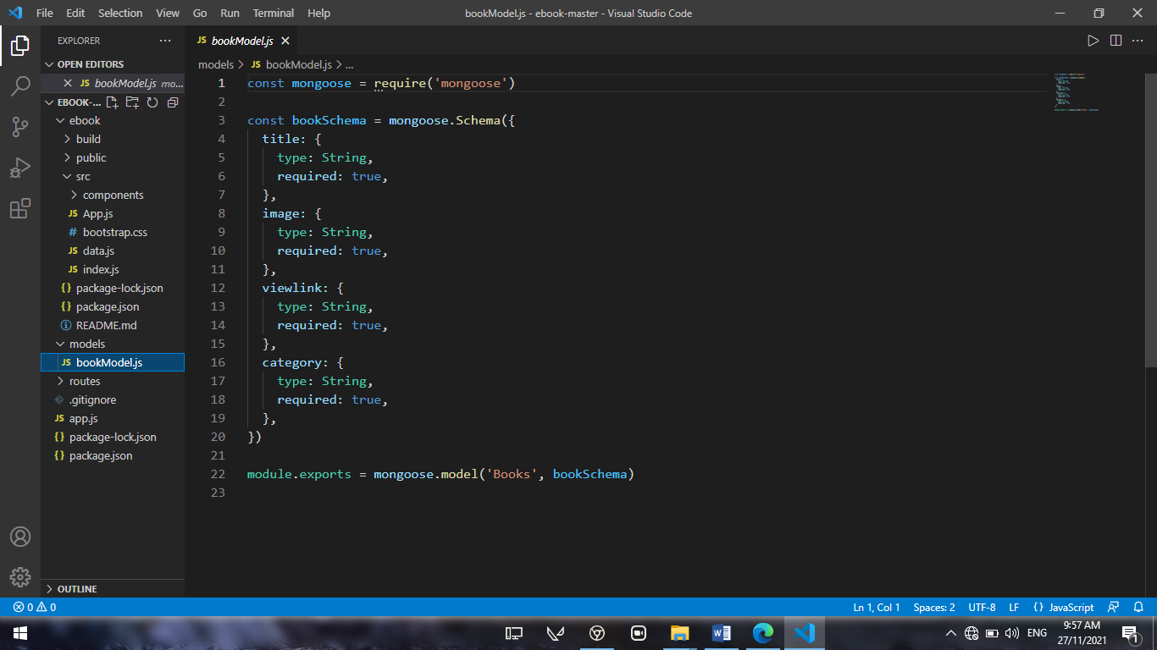

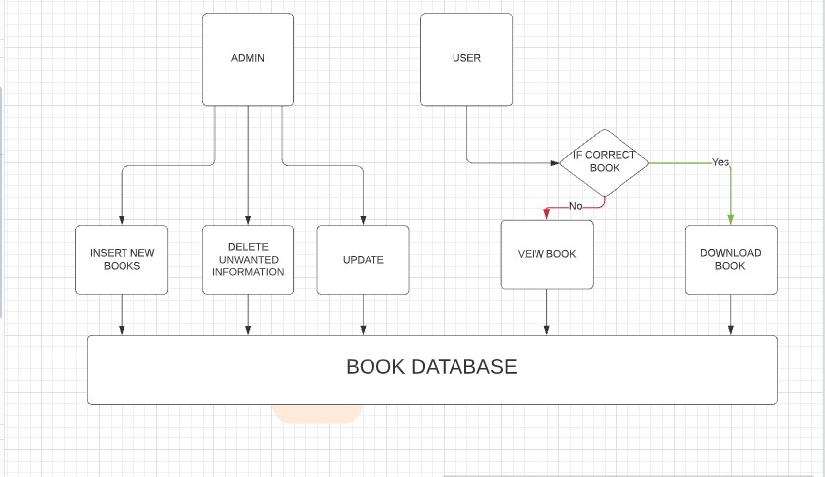4.2 Block Diagram

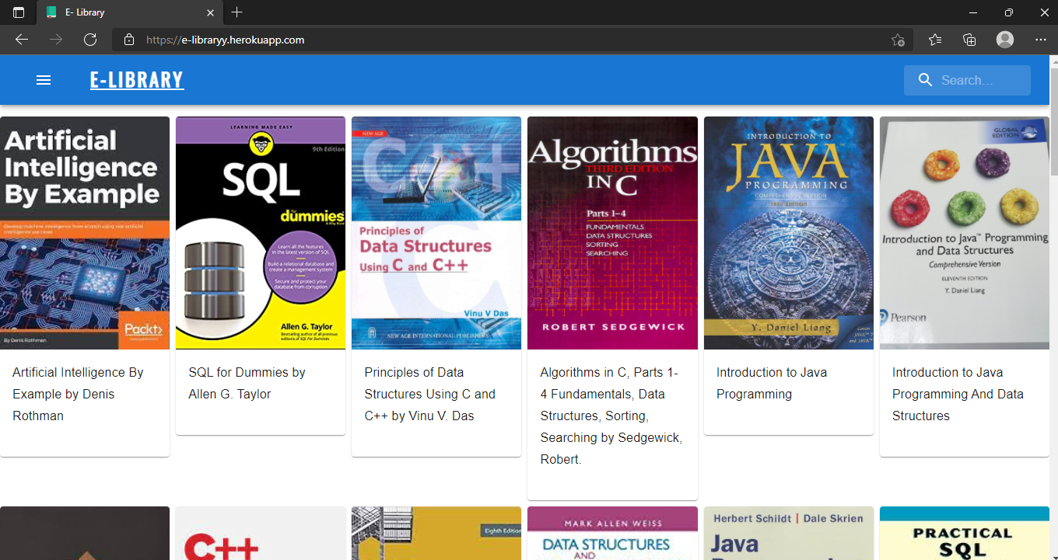4.3 Website View

Screenshots of Our Website

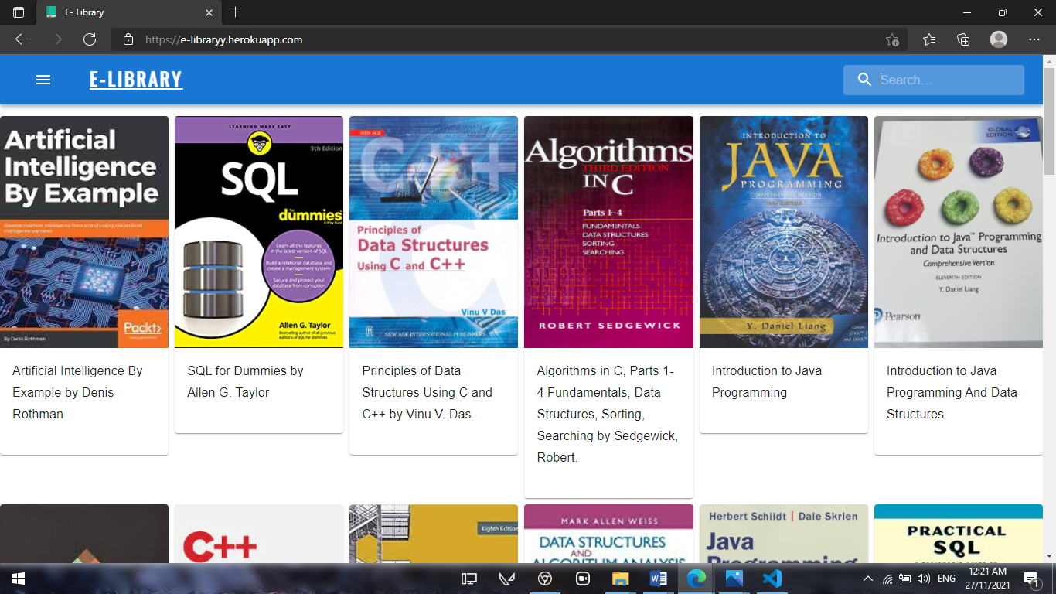

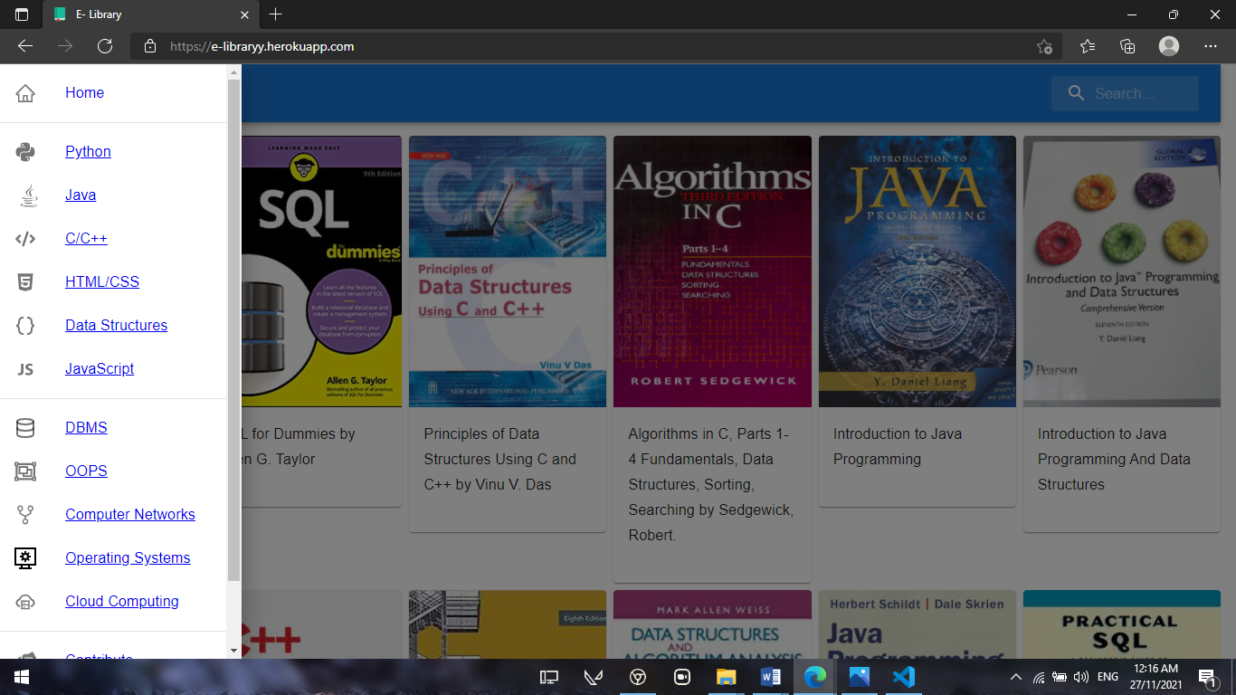

CHAPTER 5

RESULTS AND DISCUSSION

5.1 BENEFITS OF E-LIBRARY

1. You no Need to go to Library During this pandemic for Safety purpose. The main benefit of using E-Library is to gain knowledge through online textbooks and to boost your ease of use is that you don't need to have a textbook from Library. That means everyone can access the latest recommendations for their appropriate courses, including programing, Theory, long phrases, symbols, punctuation, and capitalization.
2. You can use this in an efficient way such that you can access it where ever you want. And you can get the information, which is required at that particular moment. Without having a website like this we may not have the access to that information in an efficient way to remember complicated concepts.
3. Fast Access to this usage is possible only through Technology and the Respective devices which can provide access to it, and also it allows people to Download particular textbook, when he need it offline. but also we can access many different books based on our present course to get every access point in an easier way.
4. More textbooks can be accessible through our website in an efficient way without any interruption and with a friendly user interface, such that user can access our website in a best way and also he can understand the list of contents we have provided in it.
5. And it is an Open-source website, any user can access it without and interruption and it is free of cost and with the best user interface

CHAPTER 6

CONCLUSION AND FUTURE WORK

6.1 Conclusion

This website provides a Virtual version of library, which will benefit the students as well as the persons who can’t reach out to Library. It makes entire process online where student can search books, they can generate notes. It also has a facility for downloading Books where student can gain access to their library books offline once after they download and they can also give some suggestions. It has a facility to contribute the developers and necessary suggestion for the website Development and also There is a future scope of this facility that many more features such as online lectures video tutorials can be added to it, and a feature of group chat where users can discuss various issues of engineering can be added to this project thus making it more interactive more user friendly and project which fulfills each users need in the best way possible.

REFERENCES

* <https://1lib.in/?signAll=1&ts=0732>
* <https://www.daitm.org.in/wp-content/uploads/2019/04/Gr.-06library-project-report.pdf>
* <https://www.javatpoint.com/elibrary-project-in-servlet>
* https://opus.govst.edu/cgi/viewcontent.cgi?article=1179&context=capstones